**PEMODELAN BASIS DATA**

**PADA APLIKASI TRAVELOKA**

**SPA DAN KECANTIKAN**

**Tugas Besar**

diajukan untuk memenuhi tugas besar pada mata kuliah Pemodelan Basis Data



**Oleh :**

Arib Ghalwari (1301173713)

Nugraha Kusuma Setyo E (1301170766)

Tubagus Ibrohim A (1301174655)

**PROGRAM STUDI S1 TEKNIK INFORMATIKA**

**FAKULTAS INFORMATIKA**

**UNIVERSITAS TELKOM**

**BANDUNG**

**2018**

**Business Process:**

Untuk melakukan pemesanan di traveloka, pengguna harus membuat akun terlebih dahulu yang nanti akan diisi dengan Nama, Alamat, email, password, dan nomor handphone. Setelah pengguna memiliki Akun akan otomatis mendapatkan E-Wallet. Akun dapat mengakses fitur Spa dan Kecantikan untuk melakukan pemesanan. Setelah Akun memasuki fitur Spa dan Kecantikan, Akun dapat memilih kota yang di inginkan atau rekomendasi salon dengan lokasi jarak terdekat. Setelah memilih kota yang di inginkan, Akun dapat memilih Treatment yang ingin dipesan dan Salon mana yang di inginkan untuk melakukan Treatment tersebut. Salon dan Treatment memiliki Rating serta Ulasan sendiri, yang dimana pengguna akun dapat melihat apakah salon ini cocok untuk pengguna atau tidak. Setelah memilih treatment dan salon yang di inginkan, akun akan diarahkan untuk melihat deskripsi toko, di sana akun dapat melihat detail aktivitas dari salon tersebut untuk mencocokkan apakah salon tersebut sesuai yang di inginkan oleh akun atau tidak. Di deskripsi toko ini juga ada Info Transportasi & Lokasi agar mengetahui lokasi pasti Salon tersebut. Jika merasa semua sudah sesuai keinginan, maka akun akan melakukan proses pembooking an tiket. Akun akan memilih treatment yang ada, harga dari treatment itu sendiri sudah tertera saat ingin melakukan pembooking an, setelah semua sesuai dengan keinginan akun, akun akan memilih kuantitas tiket yang ingin dipesan, setelah itu akun akan memilih tanggal dan waktu kunjungan yang di inginkan. Akun akan mengisi Data pemesanan sesuai yang akan dicetak nanti, data pemesanan berisi Nama pemesan, No telepon, Email. Setelah Data pemesan sudah diisi akun akan diminta untuk mengisi Data Traveller/Wisatawan yang berisi Nama, No Telepon dan Email. Setelah data sudah diisi akun akan menentukan tanggal dan waktu kunjungan. Setelah pengisian data selesai, akun akan memilih metode pembayaran sesuai yang di inginkan akun, harga yang akan di bayar akun adalah harga total dari seluruh pemesanan akun tersebut. Saat Pembayaran, akun dapat menggunakan kupon jika ada. Kode unik dari transaksi akan mengurangi total harga dari transaksi. Akun akan mendapatkan tenggat waktu pembayaran dari transaksi tersebut. Setelah akun sudah membayar maka dari pihak Traveloka akan memberikan Voucher/Tiket untuk dikirimkan kepada pengguna.

**Business Rules:**

1. Tiap customer harus memiliki akun.
2. 1 akun hanya bisa mem booking untuk 1 pelanggan.
3. Di tanggal yang sama akun bisa melakukan lebih dari 1 kali transaksi.
4. 1 kali booking dapat memilih treatment dan 1 tempat.
5. Kode booking digunakan untuk melakukan pembooking an.
6. Id booking digunakan untuk melakukan pembayaran.
7. Pada pilihan metode pembayaran bisa dengan atm, transfer, kartu kredit, dan di minimarket.
8. 3-digit kode unik otomatis akan mengurangi total harga
9. Voucher akan di tunjukkan setelah melakukan booking.

**ERD :**

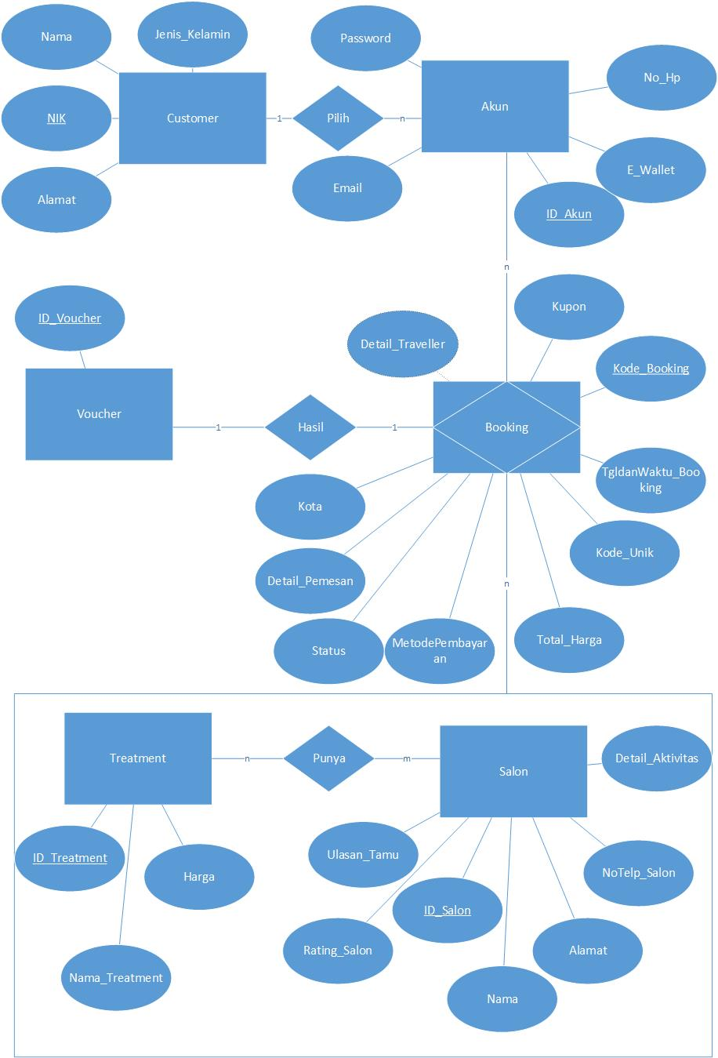

**Skema Relasi :**

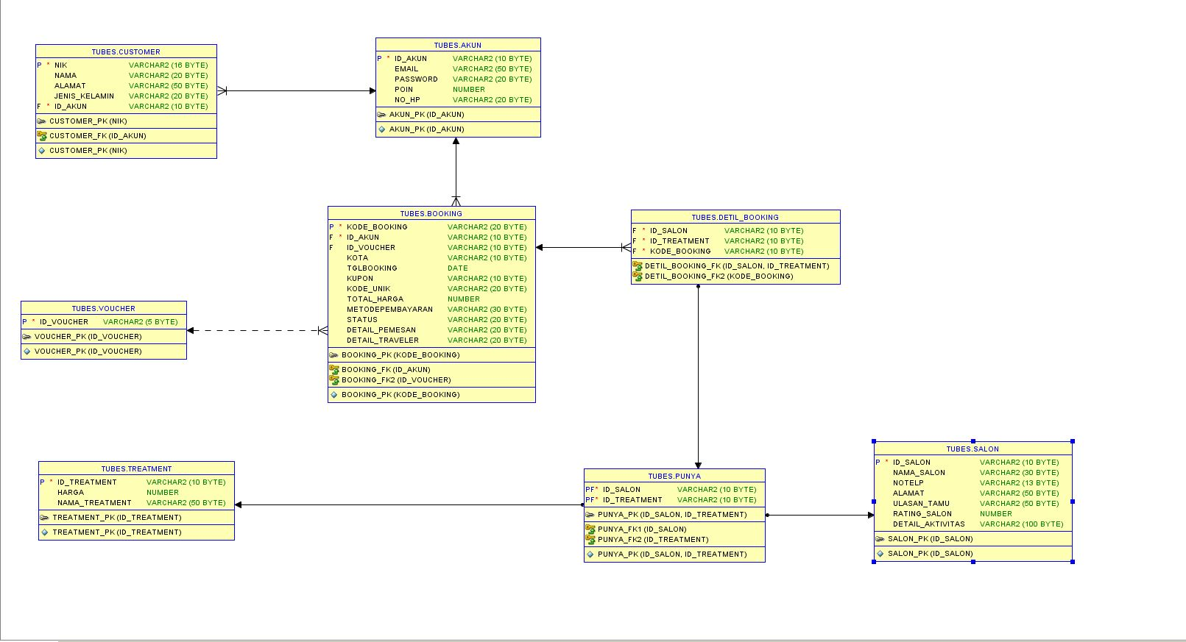

Screenshot Aplikasi :

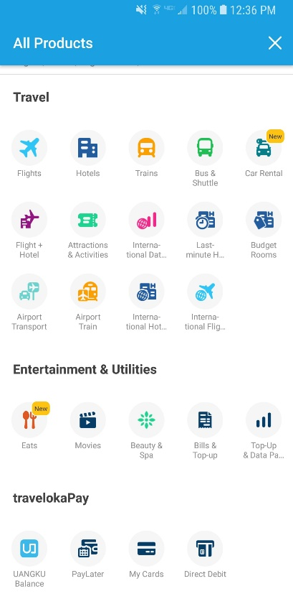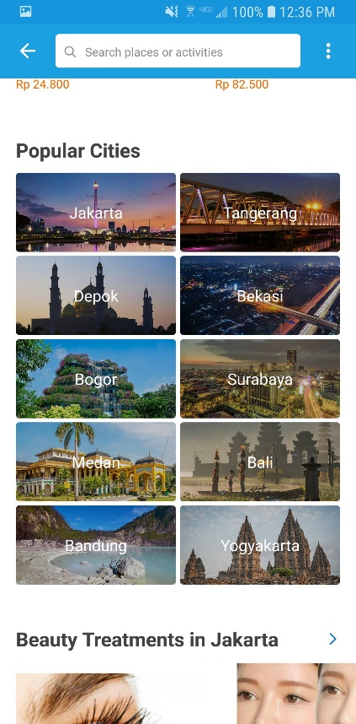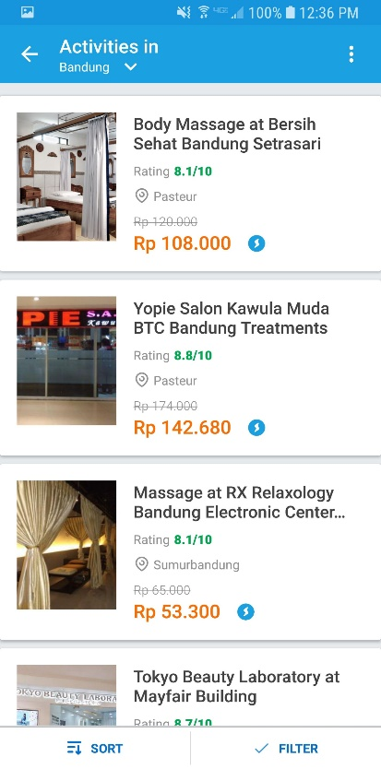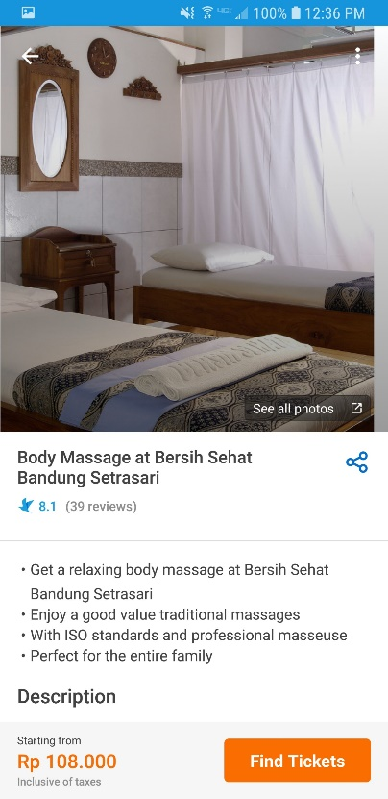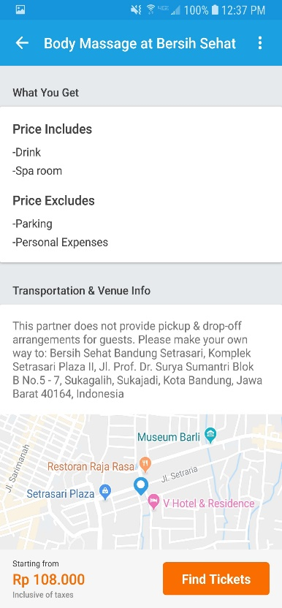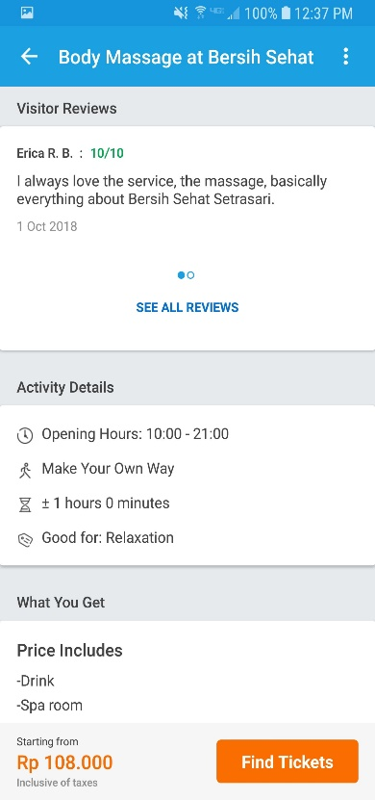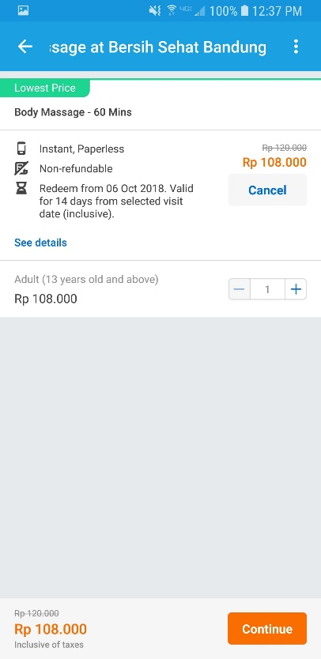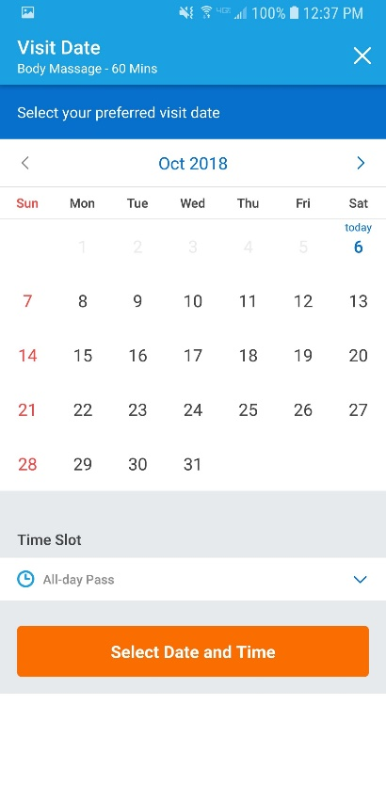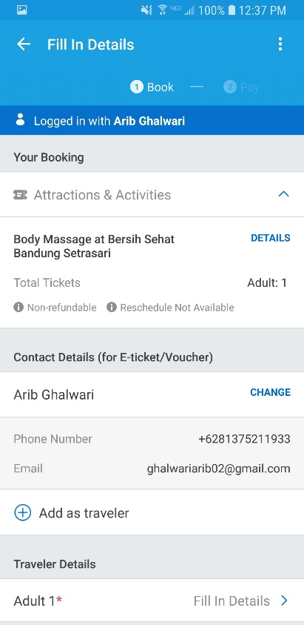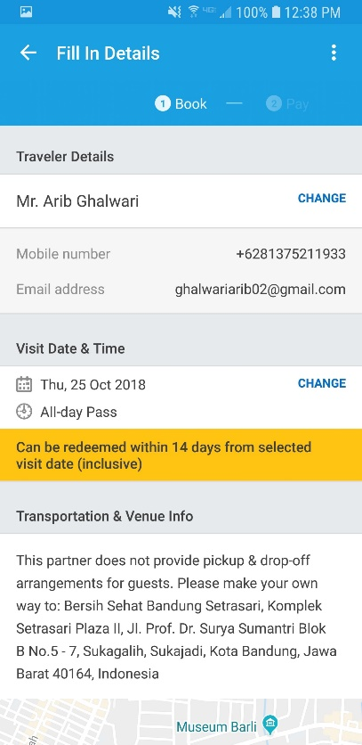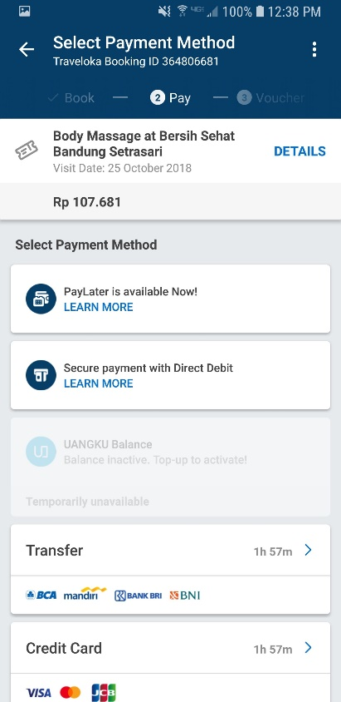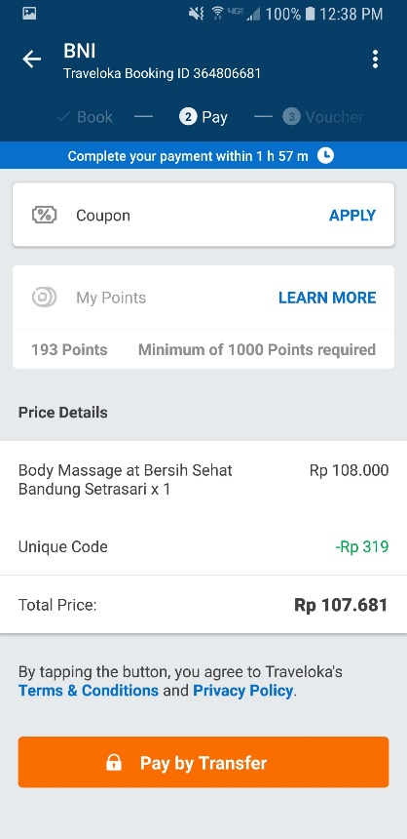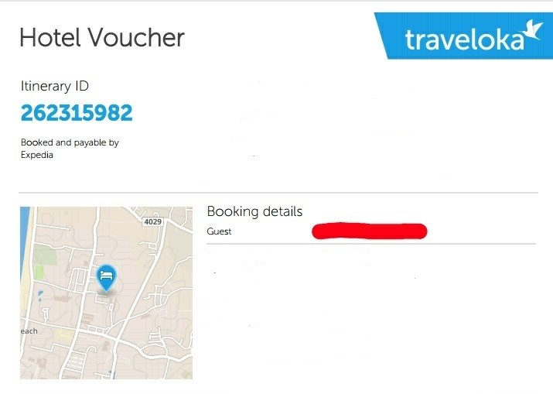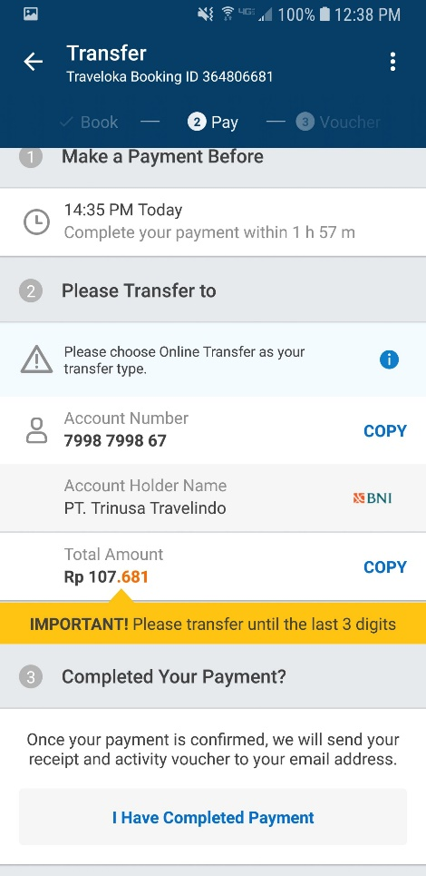

**Karena penugas belum pernah melakukan pembookingan di Spa dan Kecantikan, maka penugas mengasumsikan voucher memiliki id voucher sendiri seperti halnya pada pembookingan di fitur Hotel.**

**DDL:**

CREATE TABLE CUSTOMER (

NIK VARCHAR (16) NOT NULL ,

Nama VARCHAR (20) ,

Alamat VARCHAR (50) ,

Jenis_kelamin VARCHAR (20),

ID_AKUN VARCHAR(10) NOT NULL ) ;

CREATE TABLE AKUN (

ID_AKUN VARCHAR (10) NOT NULL ,

EMAIL VARCHAR (50) ,

PASSWORD VARCHAR(20) ,

POIN NUMBER,

NO_HP VARCHAR(20) ) ;

CREATE TABLE BOOKING (

KODE_BOOKING VARCHAR (10) ,

ID_AKUN VARCHAR(10) NOT NULL,

ID_VOUCHER VARCHAR(10) ,

KOTA VARCHAR(10) ,

TGLBOOKING DATE ,

KUPON VARCHAR(10),

KODE_UNIK VARCHAR(20),

TOTAL_HARGA NUMBER,

METODEPEMBAYARAN VARCHAR(30),

STATUS VARCHAR(20),

DETAIL_PEMESAN VARCHAR(20),

DETAIL_TRAVELER VARCHAR(20) ) ;

CREATE TABLE DETIL_BOOKING (

ID_SALON VARCHAR(10) NOT NULL,

ID_TREATMENT VARCHAR(10) NOT NULL,

KODE_BOOKING VARCHAR(10) ) ;

CREATE TABLE PUNYA (

ID_SALON VARCHAR(10) NOT NULL,

ID_TREATMENT VARCHAR(10) NOT NULL ) ;

CREATE TABLE VOUCHER (

ID_VOUCHER VARCHAR (5) NOT NULL ) ;

CREATE TABLE SALON(

ID_SALON VARCHAR (10) NOT NULL ,

NAMA_SALON VARCHAR (30) ,

NOTELP VARCHAR (13) ,

ALAMAT VARCHAR (50) ,

ULASAN_TAMU VARCHAR(50),

RATING_SALON NUMBER,

DETAIL_AKTIVITAS VARCHAR(100) ) ;

CREATE TABLE TREATMENT (

ID_TREATMENT VARCHAR (10) NOT NULL ,

HARGA NUMBER ,

NAMA_TREATMENT VARCHAR (50) ) ;

ALTER SESSION SET nls_date_format = 'dd-MM-yyyy';

ALTER TABLE CUSTOMER ADD CONSTRAINT CUSTOMER_PK PRIMARY KEY ( NIK ) ;

ALTER TABLE BOOKING ADD CONSTRAINT BOOKING_PK PRIMARY KEY ( KODE_BOOKING ) ;

ALTER TABLE AKUN ADD CONSTRAINT AKUN_PK PRIMARY KEY ( ID_AKUN ) ;

ALTER TABLE TREATMENT ADD CONSTRAINT TREATMENT_PK PRIMARY KEY ( ID_TREATMENT ) ;

ALTER TABLE VOUCHER ADD CONSTRAINT VOUCHER_PK PRIMARY KEY ( ID_VOUCHER ) ;

ALTER TABLE SALON ADD CONSTRAINT SALON_PK PRIMARY KEY ( ID_SALON ) ;

ALTER TABLE PUNYA ADD CONSTRAINT PUNYA_PK PRIMARY KEY ( ID_SALON,ID_TREATMENT) ;

ALTER TABLE CUSTOMER ADD CONSTRAINT CUSTOMER_FK FOREIGN KEY (ID_AKUN) REFERENCES AKUN(ID_AKUN);

ALTER TABLE BOOKING ADD CONSTRAINT BOOKING_FK FOREIGN KEY (ID_AKUN) REFERENCES AKUN(ID_AKUN);

ALTER TABLE BOOKING ADD CONSTRAINT BOOKING_FK2 FOREIGN KEY (ID_VOUCHER) REFERENCES VOUCHER(ID_VOUCHER);

ALTER TABLE DETIL_BOOKING ADD CONSTRAINT DETIL_BOOKING_FK FOREIGN KEY (ID_SALON,ID_TREATMENT) REFERENCES PUNYA(ID_SALON,ID_TREATMENT) ;

ALTER TABLE DETIL_BOOKING ADD CONSTRAINT DETIL_BOOKING_FK2 FOREIGN KEY(KODE_BOOKING) REFERENCES BOOKING(KODE_BOOKING);

ALTER TABLE PUNYA ADD CONSTRAINT PUNYA_FK1 FOREIGN KEY (ID_SALON) REFERENCES SALON(ID_SALON);

ALTER TABLE PUNYA ADD CONSTRAINT PUNYA_FK2 FOREIGN KEY (ID_TREATMENT) REFERENCES TREATMENT(ID_TREATMENT);

**DML:**

INSERT INTO AKUN VALUES ('A01’, ‘ANISMATTA@GMAIL.COM','ANIS123',50,'081298330921');

INSERT INTO AKUN VALUES ('A02’, ‘FARHANSSU@GMAIL.COM','FARHANAJA',34,'081273804102');

INSERT INTO AKUN VALUES ('A03’, ‘FARHATBAS@GMAIL.COM','BASBAS123',24,'085668852071');

INSERT INTO AKUN VALUES ('A04',' SANDIAGA@GMAIL.COM','UNOPRES',100,'08159121418');

INSERT INTO AKUN VALUES ('A05', 'NAJWAWA@GMAIL.COM','NAJWA31',56,'081298330927');

INSERT INTO AKUN VALUES ('A06', 'NIDAANISA@GMAIL.COM','NIDAAJA',46,'08213838999');

INSERT INTO AKUN VALUES ('A07', 'FAKHRII@GMAIL.COM','FAKHRIINI',27,'081112131415');

INSERT INTO AKUN VALUES ('A08', 'HAMZAHYO@GMAIL.COM','HAMZAHJUARA',99,'081214171819');

INSERT INTO AKUN VALUES ('A09', 'SILKASK@GMAIL.COM','SILSIL12',22,'08151001976');

INSERT INTO AKUN VALUES ('A10', 'SYIHABUSY@GMAIL.COM','AXXZ3',21,'0811693030030');

INSERT INTO AKUN VALUES ('A11', 'GITASFTR12@GMAIL.COM','SAFITRIGITA12',121,'089684491118');

INSERT INTO AKUN VALUES ('A12', 'ARIBGHAL@GMAIL.COM','GATALSEKA',17,'08154875124558');

INSERT INTO AKUN VALUES ('A13', 'NUGKUSM@GMAIL.COM','IGUNUGI',99,'0811483725111');

INSERT INTO AKUN VALUES ('A14', 'MAULASYA@GMAIL.COM','TASYAM122',86,'0812457898652');

INSERT INTO AKUN VALUES ('A15', 'HAFIDZR@GMAIL.COM','PROPE2',21,'0811693875430');

INSERT INTO AKUN VALUES ('A16', 'AZIZAHF@YAHOO.COM','ROESZXX',61,'0811875460030');

INSERT INTO AKUN VALUES ('A17', 'RINSALL@YAHOO.COM','RINSAQWE',92,'081875421584');

INSERT INTO AKUN VALUES ('A18', 'ZAKYABD99@GMAIL.COM','PSNTRNCKL',65,'081789452136');

INSERT INTO AKUN VALUES ('A19', 'PERMATAINTAN@YAHOO.COM','INTNPRMT',99,'081547895135');

INSERT INTO AKUN VALUES ('A20', 'AGILALIG@GMAIL.COM','GILSEW',55,'08124578431557');

INSERT INTO AKUN VALUES ('A21', 'TUBGSIBRHM@GMAIL.COM','TBGS21',109,'081298330926');

INSERT INTO CUSTOMER VALUES ('0003214234215672','ANIS MATTA','JAKARTA','LAKI-LAKI','A01');

INSERT INTO CUSTOMER VALUES ('0002549874561254','MUHAMMAD FARHAN','BOGOR','LAKI-LAKI','A02');

INSERT INTO CUSTOMER VALUES ('0034578912456778','FARHAT ABBAS','BANDUNG','LAKI-LAKI','A03');

INSERT INTO CUSTOMER VALUES ('0049658412547863','SANDIAGA UNO','JAKARTA','LAKI-LAKI','A04');

INSERT INTO CUSTOMER VALUES ('0052147845823563','NAJWA SYIHAB','SURABAYA','PEREMPUAN','A05');

INSERT INTO CUSTOMER VALUES ('0064785124856398','NIDA ANNISA','BANTEN','PEREMPUAN','A06');

INSERT INTO CUSTOMER VALUES ('0078745213695487','FAKHRI HARDI','BEKASI','LAKI-LAKI','A07');

INSERT INTO CUSTOMER VALUES ('0083258456128795','HAMZAH QURAISY','BOGOR','LAKI-LAKI','A08');

INSERT INTO CUSTOMER VALUES ('0093254789564213','SILKA HAMID','BOGOR','PEREMPUAN','A09');

INSERT INTO CUSTOMER VALUES ('0108745987452145','URAISH SYIHAB','JAKARTA','LAKI-LAKI','A10');

INSERT INTO CUSTOMER VALUES ('0124785698745632','GITA SAFITRI','BATAM','PEREMPUAN','A11');

INSERT INTO CUSTOMER VALUES ('7845123698756412','ARIB GHALWARI','ACEH','LAKI-LAKI','A12');

INSERT INTO CUSTOMER VALUES ('8547961245879634','NUGRAHA KUSUMA','BOGOR','LAKI-LAKI','A13');

INSERT INTO CUSTOMER VALUES ('9874561245789456','TASYA MAULA','SUKABUMI','PEREMPUAN','A14');

INSERT INTO CUSTOMER VALUES ('8546987124578965','HAFIDZ RIZKI','BATAM','LAKI-LAKI','A15');

INSERT INTO CUSTOMER VALUES ('8456213467984562','AZIZAH PUTRI','JAKARTA','PEREMPUAN','A16');

INSERT INTO CUSTOMER VALUES ('4512478795632145','RINA SALSABILLA','SURABAYA','PEREMPUAN','A17');

INSERT INTO CUSTOMER VALUES ('0001245789632585','ABDULLAH ZAKY','BANTEN','LAKI-LAKI','A18');

INSERT INTO CUSTOMER VALUES ('0000111145896325','INTAN MUTIARA','BEKASI','PEREMPUAN','A19');

INSERT INTO CUSTOMER VALUES ('8885446321025874','AGIL BAYU','KALIMANTAN','LAKI-LAKI','A20');

INSERT INTO CUSTOMER VALUES ('0002145873215988','TUBAGUS IBROHIM','JAKARTA','LAKI-LAKI','A21');

INSERT INTO VOUCHER VALUES ('VC01');

INSERT INTO VOUCHER VALUES ('VC02');

INSERT INTO VOUCHER VALUES ('VC03');

INSERT INTO VOUCHER VALUES ('VC04');

INSERT INTO VOUCHER VALUES ('VC05');

INSERT INTO VOUCHER VALUES ('VC06');

INSERT INTO VOUCHER VALUES ('VC07');

INSERT INTO VOUCHER VALUES ('VC08');

INSERT INTO VOUCHER VALUES ('VC09');

INSERT INTO VOUCHER VALUES ('VC10');

INSERT INTO VOUCHER VALUES ('VC11');

INSERT INTO VOUCHER VALUES ('VC12');

INSERT INTO VOUCHER VALUES ('VC13');

INSERT INTO VOUCHER VALUES ('VC14');

INSERT INTO VOUCHER VALUES ('VC15');

INSERT INTO VOUCHER VALUES ('VC16');

INSERT INTO VOUCHER VALUES ('VC17');

INSERT INTO VOUCHER VALUES ('VC18');

INSERT INTO VOUCHER VALUES ('VC19');

INSERT INTO VOUCHER VALUES ('VC20');

INSERT INTO BOOKING VALUES ('B01','A01','VC01','BANDUNG','10-03-2016','KPN01','456',120456,'CASH','LUNAS','ANIS MATTA','ANIS MATTA');

INSERT INTO BOOKING VALUES ('B02','A01','VC02','BANDUNG','10-03-2016','KPN01','996',130996,'CASH','LUNAS','ANIS MATTA','ISHAQ KURNIA');

INSERT INTO BOOKING VALUES ('B03','A02','VC03','JAKARTA','15-04-2017','KPN02','777',98777,'TRANSFER','WAITING','MUH FARHAN','MUH FARHAN');

INSERT INTO BOOKING VALUES ('B04','A03','VC04','BOGOR','16-03-2015','KPN03','887',61887,'CASH','LUNAS','FARHAT ABBAS','FARHAT ABBAS');

INSERT INTO BOOKING VALUES ('B05','A04','VC05','JAKARTA','23-04-2015','KPN04','226',100226,'TRANSFER','WAITING','SANDIAGA UNO','SANDIAGA UNO');

INSERT INTO BOOKING VALUES ('B06','A05','VC06','SURABAYA','16-06-2014','KPN05','669',146690,'TRANSFER','LUNAS','NAJWA SYIHAB','NAJWA SYIHAB');

INSERT INTO BOOKING VALUES ('B07','A06','VC07','BANTEN','07-11-2017','KPN06','566',45566,'CASH','LUNAS','NIDA ANNISA','NIDA ANNISA');

INSERT INTO BOOKING VALUES ('B08','A07','VC08','BEKASI','19-04-2017','KPN07','145',76145,'TRANSFER','WAITING','FAKHRI HARDI','FAKHRI HARDI');

INSERT INTO BOOKING VALUES ('B09','A08','VC09','BOGOR','22-01-2017','KPN08','132',987132,'CASH','WAITING','HAMZAH Q','HAMZAH Q');

INSERT INTO BOOKING VALUES ('B10','A09','VC10','JAKARTA','24-03-2015','KPN09','999',55999,'CASH','LUNAS','SILKA H','SILKA HAMID');

INSERT INTO BOOKING VALUES ('B11','A10','VC11','BOGOR','26-04-2016','KPN10','886',150886,'TRANSFER','LUNAS','URAISH S','URAISH SYIHAB');

INSERT INTO BOOKING VALUES ('B12','A11','VC12','BATAM','12-12-2017','KPN11','621',89621,'CASH','WAITING','GITA SAFITRI','GITA SAFITRI');

INSERT INTO BOOKING VALUES ('B12','A11','VC12','BATAM','12-12-2017','KPN11','621',89621,'CASH','WAITING','GITA SAFITRI','GITA SAFITRI');

INSERT INTO BOOKING VALUES ('B13','A12','VC13','ACEH','24-12-2016','KPN12','432',100432,'TRANSFER','LUNAS','ARIB GHALWARI','ARIB GHLWARI');

INSERT INTO BOOKING VALUES ('B14','A13','VC14','BOGOR','30-12-2016','KPN13','777',93777,'CASH','WAITING','NUGRAHA KUSUMA','NUGRAHA KUSUMA');

INSERT INTO BOOKING VALUES ('B15','A14','VC15','SUKABUMI','29-09-2018','KPN14','111',111111,'TRANSFER','WAITING','TASYA MAULA','TASYA MAULA');

INSERT INTO BOOKING VALUES ('B16','A15','VC16','BATAM','01-10-2018','KPN15','273',150273,'CASH','LUNAS','HAFIDZ RIZKI','HAFIDZ RIZKI');

INSERT INTO BOOKING VALUES ('B17','A16','VC17','JAKARTA','24-03-2018','KPN16','507',120507,'CASH','WAITING','AZIZAH PUTRI','AZIZAH PUTRI');

INSERT INTO BOOKING VALUES ('B18','A17','VC18','SURABAYA','17-07-2018','KPN17','092',212092,'TRANSFER','WAITING','RINA SALSABILLA','RINA SALSABILA');

INSERT INTO BOOKING VALUES ('B19','A18','VC19','BANTEN','08-08-2018','KPN18','811',90811,'CASH','LUNAS','ABDULLAH ZAKY','ABDULLAH ZAKY');

INSERT INTO BOOKING VALUES ('B20','A19','VC20','BEKASI','12-06-2018','KPN19','079',170079,'CASH','LUNAS','INTAN MUTIARA','INTAN MUTIARA');

INSERT INTO BOOKING VALUES ('B21','A20','VC21','KALIMANTAN','02-05-2018','KPN20','456',250456,'TRANSFER','LUNAS','AGIL BAYU','AGIL BAYU');

INSERT INTO BOOKING VALUES ('B22','A02','VC03','JAKARTA','10-03-2017','KPN02','896',112896,'CASH','LUNAS','MUH FARHAN','JULIAN FARHAN');

INSERT INTO BOOKING VALUES ('B23','A03','VC04','BOGOR','19-03-2016','KPN03','952',81952,'CASH','LUNAS','FARHAT ABBAS','ALFI YULISTYAN');

INSERT INTO BOOKING VALUES ('B24','A04','VC05','JAKARTA','23-04-2016','KPN04','786',123786,'TRANSFER','WAITING','SANDIAGA UNO','PRABOWO SUBIANTO');

INSERT INTO BOOKING VALUES ('B25','A05','VC06','SURABAYA','16-06-2015','KPN05','623',146623,'TRANSFER','LUNAS','NAJWA SYIHAB','EDY SOPANDI');

INSERT INTO BOOKING VALUES ('B26','A06','VC07','BANTEN','23-12-2017','KPN06','442',32442,'CASH','LUNAS','NIDA ANNISA','RAHMA AINUN');

INSERT INTO BOOKING VALUES ('B27','A07','VC08','BEKASI','20-05-2017','KPN07','233',51233,'TRANSFER','WAITING','FAKHRI HARDI','SHOFWAN MUTQ');

INSERT INTO BOOKING VALUES ('B28','A08','VC09','BOGOR','24-05-2018','KPN08','555',932555,'CASH','WAITING','HAMZAH Q','FAILZA HARYO');

INSERT INTO BOOKING VALUES ('B29','A09','VC10','JAKARTA','10-07-2015','KPN09','313',42313,'CASH','LUNAS','SILKA H','SANY ARDI');

INSERT INTO BOOKING VALUES ('B30','A10','VC11','BOGOR','12-05-2016','KPN10','865',91865,'TRANSFER','LUNAS','URAISH S','NADIA SYAFI');

INSERT INTO BOOKING VALUES ('B31','A11','VC12','BATAM','13-01-2018','KPN11','413',63413,'CASH','WAITING','GITA SAFITRI','RAFIF IHDAR');

INSERT INTO BOOKING VALUES ('B32','A11','VC12','BATAM','12-04-2018','KPN11','231',89231,'CASH','WAITING','GITA SAFITRI','ARIEF RAHMAN');

INSERT INTO BOOKING VALUES ('B33','A12','VC13','ACEH','22-13-2017','KPN12','314',100314,'TRANSFER','LUNAS','ARIB GHALWARI','AGHASYI');

INSERT INTO BOOKING VALUES ('B34','A13','VC14','BOGOR','30-01-2017','KPN13','774',93774,'CASH','WAITING','NUGRAHA KUSUMA','EDGAR KUSUMA');

INSERT INTO BOOKING VALUES ('B35','A14','VC15','SUKABUMI','31-09-2018','KPN14','222',222222,'TRANSFER','WAITING','TASYA MAULA','SUTISNA SULE');

INSERT INTO BOOKING VALUES ('B36','A15','VC16','BATAM','11-12-2018','KPN15','723',85723,'CASH','LUNAS','HAFIDZ RIZKI','FARHAN MAULANA');

INSERT INTO BOOKING VALUES ('B37','A16','VC17','JAKARTA','16-05-2018','KPN16','613',44613,'CASH','WAITING','AZIZAH PUTRI','AEDHELWIS');

INSERT INTO BOOKING VALUES ('B38','A17','VC18','SURABAYA','21-08-2018','KPN17','532',22532,'TRANSFER','WAITING','RINA SALSABILLA','PRASETYA');

INSERT INTO BOOKING VALUES ('B39','A18','VC19','BANTEN','09-09-2018','KPN18','242',51242,'CASH','LUNAS','ABDULLAH ZAKY','FAKHIRA INTAN');

INSERT INTO BOOKING VALUES ('B40','A19','VC20','BEKASI','12-08-2018','KPN19','412',17412,'CASH','LUNAS','INTAN MUTIARA','PERMATA BUAH');

INSERT INTO TREATMENT VALUES ('TRT01',52000,'CREAMBATH');

INSERT INTO TREATMENT VALUES ('TRT02',75000,'HAIRCUT');

INSERT INTO TREATMENT VALUES ('TRT03',175000,'MENICURE AND PEDICURE');

INSERT INTO TREATMENT VALUES ('TRT04',147500,'REBONDING');

INSERT INTO TREATMENT VALUES ('TRT05',138000,'MASSAGES');

INSERT INTO TREATMENT VALUES ('TRT06',90000,'FACIAL');

INSERT INTO TREATMENT VALUES ('TRT07',50000,'EAR CANDLE');

INSERT INTO TREATMENT VALUES ('TRT08',30000,'WASH AND BLOW HAIR');

INSERT INTO TREATMENT VALUES ('TRT09',60000,'CURLY HAIR');

INSERT INTO TREATMENT VALUES ('TRT10',50000,'CATOK');

INSERT INTO TREATMENT VALUES ('TRT11',100000,'LULUR');

INSERT INTO TREATMENT VALUES ('TRT12',70000,'BLEACHING');

INSERT INTO TREATMENT VALUES ('TRT13',230000,'ANTI AGING FACIAL');

INSERT INTO TREATMENT VALUES ('TRT14',70000,'TOTOK WAJAH');

INSERT INTO TREATMENT VALUES ('TRT15',320000,'TANAM BENANG');

INSERT INTO TREATMENT VALUES ('TRT16',50000,'MESOTERAPI');

INSERT INTO TREATMENT VALUES ('TRT17',650000,'LASER TERAPI');

INSERT INTO TREATMENT VALUES ('TRT18',550000,'CHEMICAL PEELING');

INSERT INTO TREATMENT VALUES ('TRT19',230000,'BOTOX WAJAH');

INSERT INTO TREATMENT VALUES ('TRT20',120000,'INTENSED PULSED LIGHT');

INSERT INTO SALON VALUES ('SLN01','JOHNNY AND ANDREAN','08125437123','JAKARTA','SANGAT BAGUS',5,'SALON TREATMENT');

INSERT INTO SALON VALUES ('SLN02','EIFFEL BEAUTY CENTER','02518334592','BOGOR, JL. RAYA PAJAJARAN NO.29','SANGAT BAGUS',5,'SALON BEAUTY');

INSERT INTO SALON VALUES ('SLN03','SARI SALON AND RIAS PENGANTIN','08161165695','JALAN CILENDEK BARAT','BAGUS',4,'SALON BEAUTY');

INSERT INTO SALON VALUES ('SLN04','SARI SALON','02518313853','BOGOR, JL. ABESIN NO.10','BAGUS',3,'SALON BEAUTY');

INSERT INTO SALON VALUES ('SLN05','RATUNA BEAUTY CARE','081212319948','YASMIN BOGOR','BAGUS',4,'SALON BEAUTY');

INSERT INTO SALON VALUES ('SLN06','CITRA SALON','082210717125','DRAMAGA BOGOR','SANGAT BAGUS',5,'SALON BEAUTY');

INSERT INTO SALON VALUES ('SLN07','PANGKAS RAMBUT DINAMIS','081210562987','BOGOR JL. CEMPLANG LAMA NO.20','SANGAT BAGUS',5,'SALON RAMBUT');

INSERT INTO SALON VALUES ('SLN08','VIE SALON','089669867888','BOGOR KOTA','BAGUS',3,'SALON BEAUTY');

INSERT INTO SALON VALUES ('SLN09','RENGGANIS SALON','02158323543','BOGOR JL. BANGBARUNG RAYA NO.40','SANGAT BAGUS',4,'SALON BEAUTY');

INSERT INTO SALON VALUES ('SLN10','REGESH SALON','0225229300','KOTA BANDUNG','SANGAT BAGUS',4,'SALON BEAUTY');

INSERT INTO SALON VALUES ('SLN11','YUYUN MAKEUP','081313363631','KOTA BANDUNG','SANGAT BAGUS',4,'SALON BEAUTY');

INSERT INTO SALON VALUES ('SLN12','EL TWENTY','0227503360','KOTA BANDUNG','BAGUS',3,'SALON BEAUTY');

INSERT INTO SALON VALUES ('SLN13','GINA SALON','082315095339','JL.KOPO PERMAI III NO.20 BANDUNG','SANGAT BAGUS',4,'SALON BEAUTY');

INSERT INTO SALON VALUES ('SLN14','UNNA HAIR AND BEAUTY','0224204313','KOTA BANDUNG','SANGAT BAGUS',4,'SALON BEAUTY');

INSERT INTO SALON VALUES ('SLN15','MIRA BEAUTY','0227536476','KOTA BANDUNG','BAGUS',4,'SALON BEAUTY');

INSERT INTO SALON VALUES ('SLN16','VONNY SALON','0225412639','KOTA BANDUNG','BAGUS',4,'SALON BEAUTY');

INSERT INTO SALON VALUES ('SLN17','HARUMI RUMAH CANTIK','0811222022','BATUNUNGGAL KOTA BANDUNG','SANGAT BAGUS',5,'SALON BEAUTY');

INSERT INTO SALON VALUES ('SLN18','FELICE SALON','0222031803','JL. SILIWANGI NO.20 KOTA BANDUNG','SANGAT BAGUS',4,'SALON KECANTIKAN');

INSERT INTO SALON VALUES ('SLN19','CIU HAIR SHOP','0225473623','BRAGA SUMUR BANDUNG','BAGUS',3,'SALON RAMBUT');

INSERT INTO SALON VALUES ('SLN20','NYKY SALON','085621591000','KOTA BANDUNG','SANGAT BAGUS',5,'SALON RAMBUT');

INSERT INTO PUNYA VALUES ('SLN01','TRT01');

INSERT INTO PUNYA VALUES ('SLN02','TRT02');

INSERT INTO PUNYA VALUES ('SLN03','TRT03');

INSERT INTO PUNYA VALUES ('SLN04','TRT04');

INSERT INTO PUNYA VALUES ('SLN05','TRT05');

INSERT INTO PUNYA VALUES ('SLN06','TRT06');

INSERT INTO PUNYA VALUES ('SLN07','TRT06');

INSERT INTO PUNYA VALUES ('SLN08','TRT01');

INSERT INTO PUNYA VALUES ('SLN09','TRT02');

INSERT INTO PUNYA VALUES ('SLN10','TRT03');

INSERT INTO PUNYA VALUES ('SLN11','TRT04');

INSERT INTO PUNYA VALUES ('SLN12','TRT05');

INSERT INTO PUNYA VALUES ('SLN13','TRT06');

INSERT INTO PUNYA VALUES ('SLN14','TRT06');

INSERT INTO PUNYA VALUES ('SLN15','TRT01');

INSERT INTO PUNYA VALUES ('SLN16','TRT02');

INSERT INTO PUNYA VALUES ('SLN17','TRT03');

INSERT INTO PUNYA VALUES ('SLN18','TRT04');

INSERT INTO PUNYA VALUES ('SLN19','TRT05');

INSERT INTO PUNYA VALUES ('SLN20','TRT06');

INSERT INTO PUNYA VALUES ('SLN01','TRT07');

INSERT INTO PUNYA VALUES ('SLN02','TRT08');

INSERT INTO PUNYA VALUES ('SLN03','TRT09');

INSERT INTO PUNYA VALUES ('SLN04','TRT10');

INSERT INTO PUNYA VALUES ('SLN05','TRT11');

INSERT INTO PUNYA VALUES ('SLN06','TRT12');

INSERT INTO PUNYA VALUES ('SLN07','TRT13');

INSERT INTO PUNYA VALUES ('SLN08','TRT14');

INSERT INTO PUNYA VALUES ('SLN09','TRT15');

INSERT INTO PUNYA VALUES ('SLN10','TRT16');

INSERT INTO PUNYA VALUES ('SLN11','TRT17');

INSERT INTO PUNYA VALUES ('SLN12','TRT18');

INSERT INTO PUNYA VALUES ('SLN13','TRT19');

INSERT INTO PUNYA VALUES ('SLN14','TRT20');

INSERT INTO DETIL_BOOKING VALUES ('SLN01','TRT01','B01');

INSERT INTO DETIL_BOOKING VALUES ('SLN01','TRT01','B02');

INSERT INTO DETIL_BOOKING VALUES ('SLN02','TRT02','B03');

INSERT INTO DETIL_BOOKING VALUES ('SLN03','TRT03','B04');

INSERT INTO DETIL_BOOKING VALUES ('SLN04','TRT04','B05');

INSERT INTO DETIL_BOOKING VALUES ('SLN05','TRT05','B06');

INSERT INTO DETIL_BOOKING VALUES ('SLN06','TRT06','B07');

INSERT INTO DETIL_BOOKING VALUES ('SLN07','TRT06','B08');

INSERT INTO DETIL_BOOKING VALUES ('SLN08','TRT01','B09');

INSERT INTO DETIL_BOOKING VALUES ('SLN09','TRT02','B10');

INSERT INTO DETIL_BOOKING VALUES ('SLN10','TRT03','B11');

INSERT INTO DETIL_BOOKING VALUES ('SLN11','TRT04','B12');

INSERT INTO DETIL_BOOKING VALUES ('SLN12','TRT05','B13');

INSERT INTO DETIL_BOOKING VALUES ('SLN13','TRT06','B14');

INSERT INTO DETIL_BOOKING VALUES ('SLN14','TRT06','B15');

INSERT INTO DETIL_BOOKING VALUES ('SLN15','TRT01','B16');

INSERT INTO DETIL_BOOKING VALUES ('SLN16','TRT02','B17');

INSERT INTO DETIL_BOOKING VALUES ('SLN17','TRT03','B18');

INSERT INTO DETIL_BOOKING VALUES ('SLN18','TRT04','B19');

INSERT INTO DETIL_BOOKING VALUES ('SLN19','TRT05','B20');

INSERT INTO DETIL_BOOKING VALUES ('SLN01','TRT07','B21');

INSERT INTO DETIL_BOOKING VALUES ('SLN02','TRT08','B22');

INSERT INTO DETIL_BOOKING VALUES ('SLN03','TRT09','B23');

INSERT INTO DETIL_BOOKING VALUES ('SLN04','TRT10','B24');

INSERT INTO DETIL_BOOKING VALUES ('SLN05','TRT11','B25');

INSERT INTO DETIL_BOOKING VALUES ('SLN06','TRT12','B26');

INSERT INTO DETIL_BOOKING VALUES ('SLN07','TRT13','B27');

INSERT INTO DETIL_BOOKING VALUES ('SLN08','TRT14','B28');

INSERT INTO DETIL_BOOKING VALUES ('SLN09','TRT15','B29');

INSERT INTO DETIL_BOOKING VALUES ('SLN10','TRT16','B30');

INSERT INTO DETIL_BOOKING VALUES ('SLN11','TRT17','B31');

INSERT INTO DETIL_BOOKING VALUES ('SLN12','TRT18','B32');

INSERT INTO DETIL_BOOKING VALUES ('SLN13','TRT19','B33');

INSERT INTO DETIL_BOOKING VALUES ('SLN14','TRT20','B34');

INSERT INTO DETIL_BOOKING VALUES ('SLN20','TRT06','B35');

INSERT INTO DETIL_BOOKING VALUES ('SLN16','TRT02','B36');

INSERT INTO DETIL_BOOKING VALUES ('SLN17','TRT03','B37');

INSERT INTO DETIL_BOOKING VALUES ('SLN18','TRT04','B38');

INSERT INTO DETIL_BOOKING VALUES ('SLN19','TRT05','B39');

INSERT INTO DETIL_BOOKING VALUES ('SLN20','TRT06','B40');

**SCRIPT QUERY:**

**Tubagus Ibrohim (1301174655):**

**--1. MENAMPILKAN NAMA DAN HARGA CUSTOMER YANG HARGANYA LEBIH DARI AKUN DENGAN ID A02 YG MEMESAN PADA BULAN MARET**

SELECT NAMA, TOTAL_HARGA

FROM CUSTOMER

JOIN AKUN USING (ID_AKUN)

JOIN BOOKING USING (ID_AKUN)

WHERE TOTAL_HARGA > (SELECT TOTAL_HARGA

FROM BOOKING

JOIN AKUN USING(ID_AKUN)

WHERE ID_AKUN = 'A02' AND TGLBOOKING LIKE '%03%')

ORDER BY NAMA;

**--2. MENAMPILKAN NAMA PEMESAN DAN NAMA YANG DIPESANKAN SALON SERTA HARGA YANG TOTAL HARGANYA KURANG DARI HARGA TERMAHAL DITREATMENT**

SELECT DETAIL_PEMESAN, DETAIL_TRAVELER, NAMA_SALON, HARGA AS "TOTAL HARGA MEMESAN"

FROM BOOKING

JOIN DETIL_BOOKING USING (KODE_BOOKING)

JOIN SALON USING (ID_SALON)

JOIN TREATMENT USING (ID_TREATMENT)

GROUP BY DETAIL_PEMESAN, DETAIL_TRAVELER, NAMA_SALON, HARGA

HAVING SUM(HARGA) < (SELECT MAX(HARGA) FROM TREATMENT)

ORDER BY DETAIL_PEMESAN;

**--3.MENAMPILKAN NAMA SALON TREATMENT HARGA ULASAN TAMU SERTA RATING SALON YANG HARGANYA**

**-- KURANG DARI HARGA MAKSIMAL DI TREATMENT**

SELECT NAMA_SALON, NAMA_TREATMENT, HARGA, ULASAN_TAMU, RATING_SALON

FROM SALON

JOIN PUNYA USING(ID_SALON)

JOIN TREATMENT USING (ID_TREATMENT)

WHERE HARGA < (SELECT MAX(HARGA)FROM TREATMENT)

ORDER BY ULASAN_TAMU, RATING_SALON;